**Exercise 1: Setting Up JUnit**

**Output:**

**Screenshot of Eclipse Project Structure:**

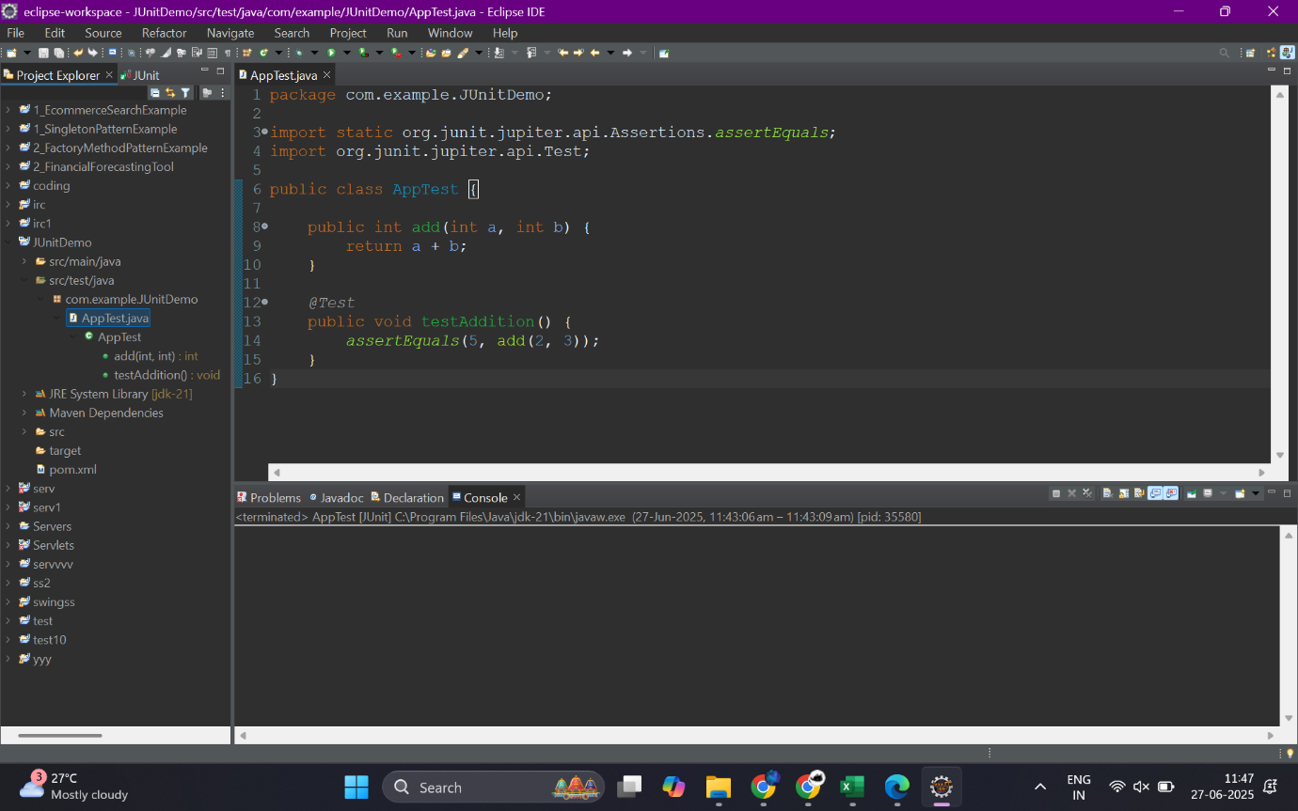

**JUnit Test Code:**

package com.example.JUnitDemo;

import static org.junit.jupiter.api.Assertions.assertEquals;

import org.junit.jupiter.api.Test;

public class AppTest {

public int add(int a, int b) {

return a + b;

}

@Test

public void testAddition() {

assertEquals(5, add(2, 3));

}

}

**Screenshot of Successful Test Run:**

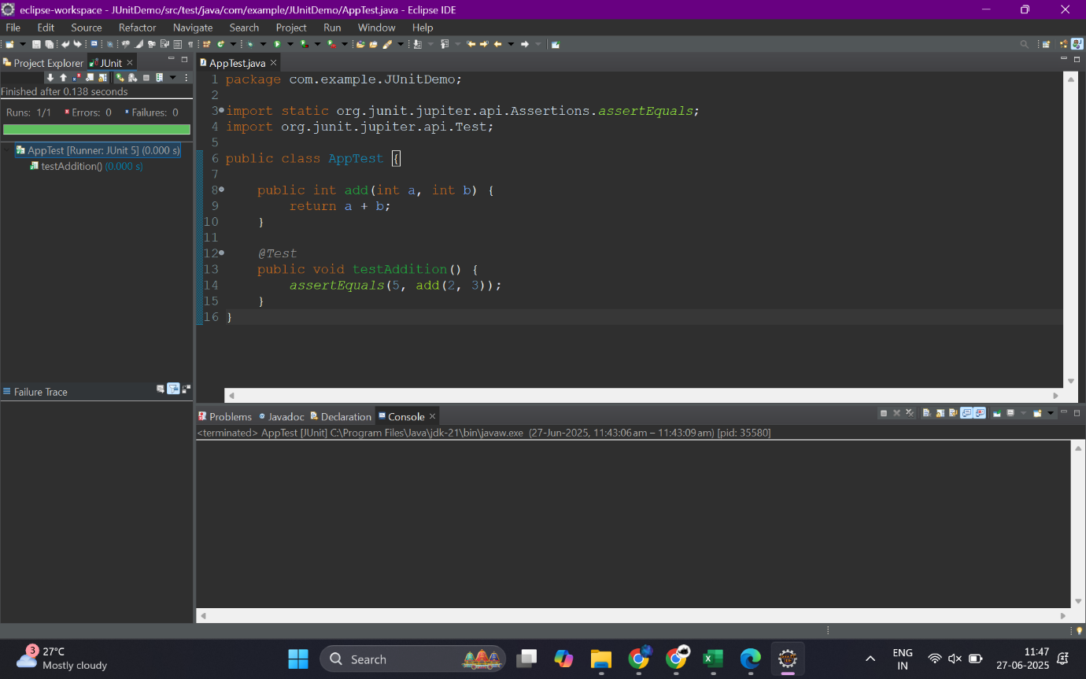

I successfully created a Maven-based Java project using Eclipse and the maven-archetype-quickstart. I added the JUnit dependency (JUnit 5.11.0), wrote a simple add() method, and verified its correctness using a unit test. The test was executed using Eclipse's JUnit runner and passed successfully, confirming the setup is complete.